

**IRIS**

Table of contents

Hardware list………………………..3

Pinout…………………………………..6

Ventilation diagram……………..7

Sensor location…………………….8

Database structure……………….9

General commands……………..10

Paths to vital files…………………11

**Hardware list**

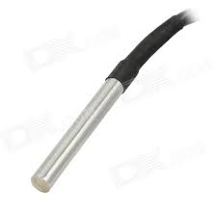

ds18b20 waterproof temperature sensor x3

* 28-000006c8044b (Tout)
* 28-041591ae04ff (Tin2)
* 28-01159110bcff (Tin3)

DHT 22 temperature / humidity sensor

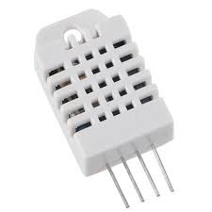

RFID-RC522

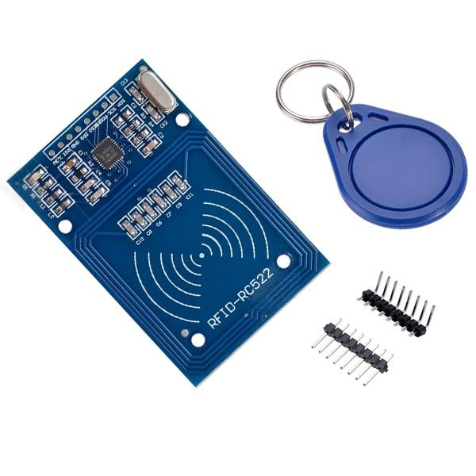

HC-SR501 IR motion sensor

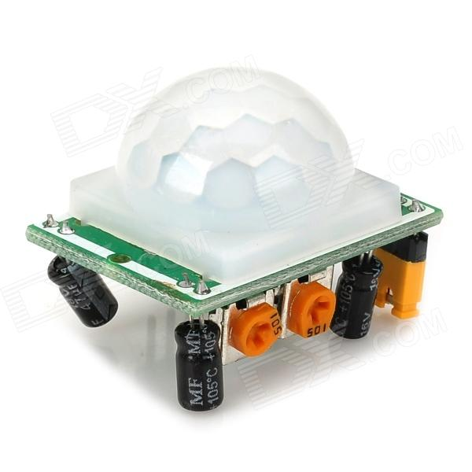

SainSmart 8 Channel DC 5V Relay

Raspberry pi

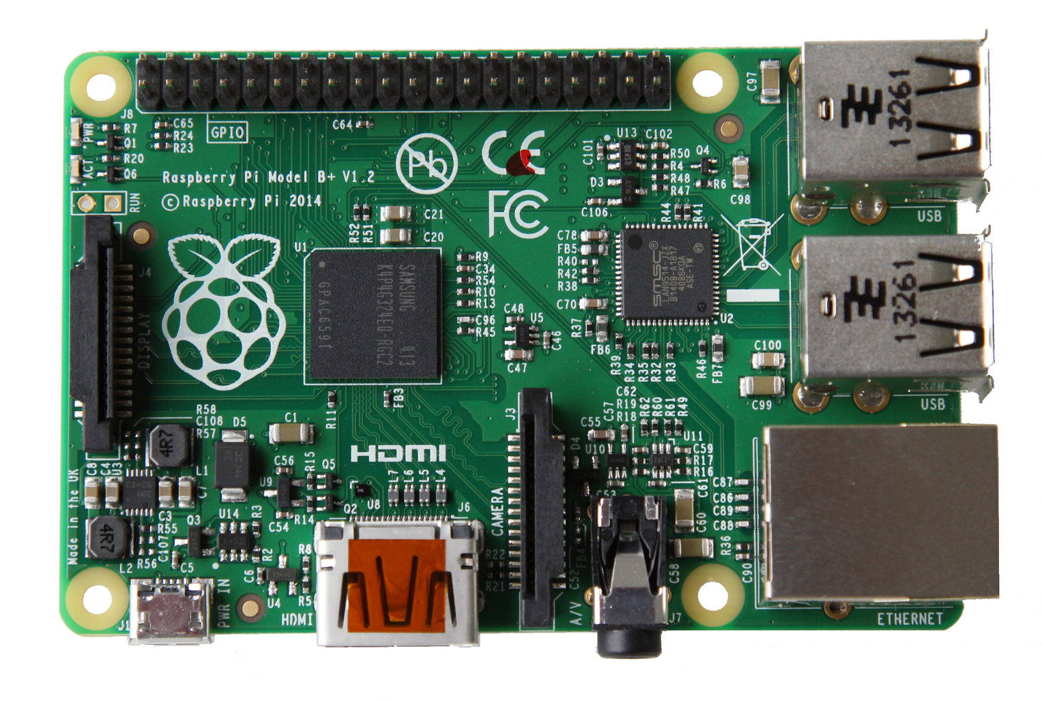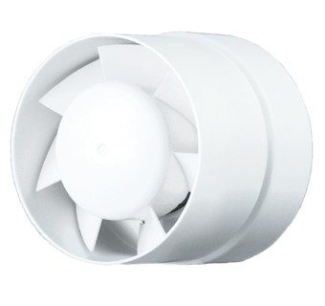

VENTS 100 VKO in-line fan x2

Ralink RT 5370

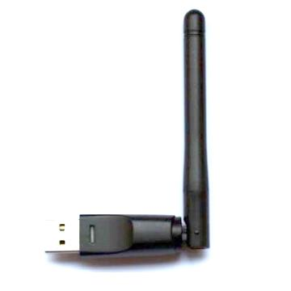

5mm LED Diode

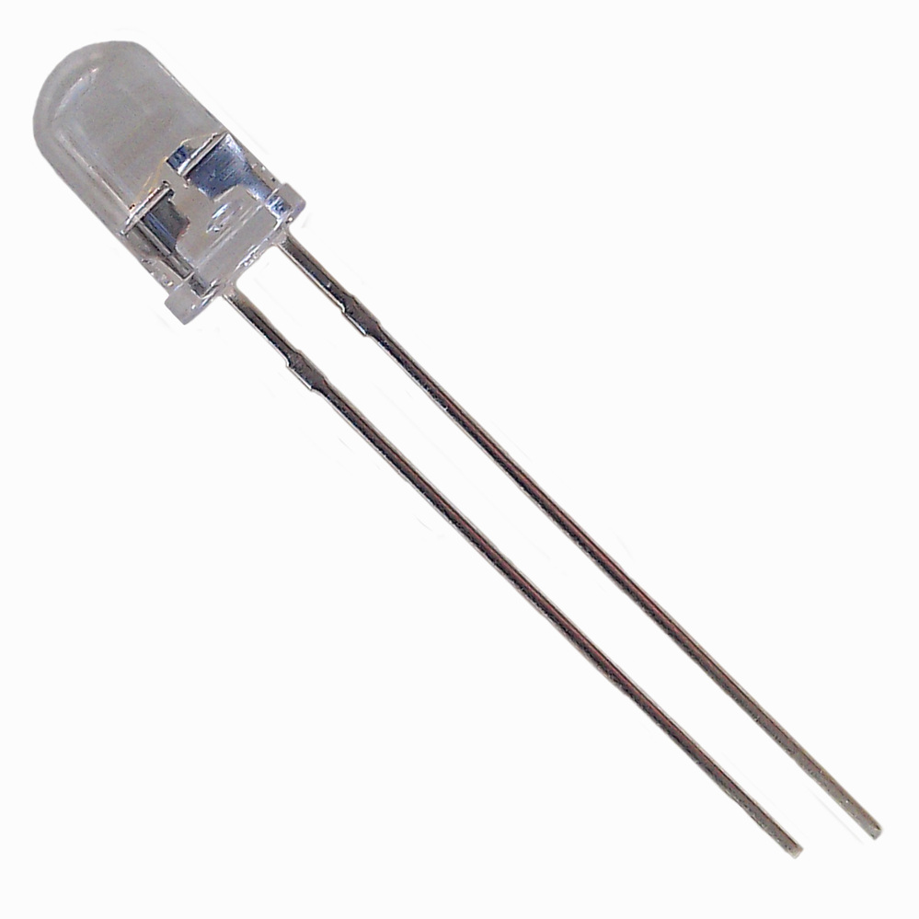

**Pinout**

|  |  |
| --- | --- |
| Relay | |
| Gpio 5 | In1 |
| Gpio 6 | in2 |
| Gpio 12 | in3 |
| Gpio 13 | in4 |
| Gpio 16 | in5 |
| Gpio 19 | in6 |
| Gpio 20 | in7 |
| Gpio 26 | in8 |
| 5v | Vcc |
| Ground | GND |

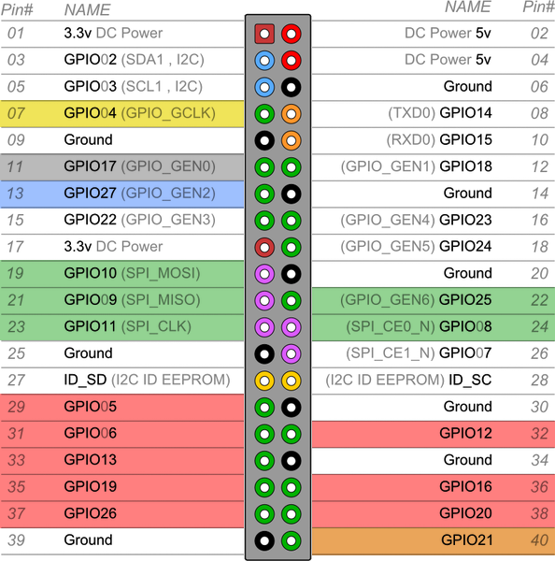

|  |  |
| --- | --- |
| DHT 22 | |
| Gpio 4 | I/O |
| 3.3v | Vcc |
| Ground | GND |

|  |  |
| --- | --- |
| HC-SR501 | |
| Gpio 21 | OUT |
| 5v | Vcc |
| Ground | GND |

|  |  |
| --- | --- |
| RFID-RC522 | |
| Gpio 8 | SDA |
| Gpio 9 | MISO |
| Gpio 10 | MOSI |
| Gpio 11 | SCK |
| Gpio 25 | RST |
| 3.3v | Vcc |
| - | IRQ |
| Ground | GND |

|  |  |
| --- | --- |
| DS18B20 | |
| Gpio 27 | I/O |
| 3.3v | Vcc |
| Ground | GND |

|  |  |
| --- | --- |
| Led diode | |
| Gpio 17 | Anode |
| Ground | Cathode |

**Ventilation diagram**

|  |  |  |  |  |
| --- | --- | --- | --- | --- |
| Auto | Closed door | <=-5 | Always off | CD4 |
| -4 - -1 | 1m(14m) | CD2 |
| 0-10 | 1m(4m) | CD1 |
| 11-17 | 1m(2m) | CD0 |
| 18-25 | 1m(4m) | CD1 |
| 26-29 | 1m(14m) | CD2 |
| >=30 | Always off | CD4 |
| Opened door | <=-5 | Always off | OD11 |
| -1 - -4 | 1m(14m) | OD01 |
| 0-19 | Always on | OD02 |
| >=20 | 1m(5m) | OD12 |

|  |  |  |
| --- | --- | --- |
| Manual | Always on | M4 |
| Always off | M3 |
| 1m(2m) | M0 |
| 1m(3m) | M1 |
| 1m(5m) | M2 |

**C:\Users\Niar\AppData\Local\Microsoft\Windows\INetCache\Content.Word\legend.png**

Ventilation legend1m(4m) =

on off

**Sensor location**

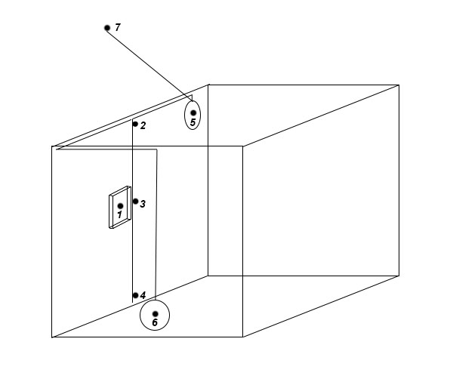

1 – Raspberry Pi

2, 4 – Temperature sensor (ds18b20)

4 – Temperature\Humidity sensor (DHT 22)

5, 6 – in-line fan

7 – outdoor temperature sensor (ds18b20)

**Database structure**

Path: /home/pi/dht.bd

meteotable(date DATETIME, tempinone TEXT, humin TEXT, tempintwo TEXT, tempinthree TEXT, tempout TEXT)

**General commands**

You will need them when something goes wrong.

*start supervisord*

sudo /usr/local/bin/supervisord –c /etc/supervisord.conf

*start all processes by autostart file*

sudo /usr/local/bin/supervisorctl –c /etc/supervisord.conf start all

*manually start specified script*

Supervisorctl start scriptname

*manually stop specified script*

Supervisorctl stop scriptname

*check status of running scripts*

Supervisorctl status

*close process by pid*

kill *pid* TERM

Exitcodes: 0, 2

Stopsignal: TERM

Autostart file: /etc/rc.local

*Manually start Wi-Fi hotspot*

sudo ifconfig wlan0 192.168.42.1

sh /etc/network/if-up.d/router.sh

**Paths to vital files**

Scripts:

/home/pi/zend_dht/MeteoStation13.py *Main script*

MeteoStation-sterr.log

MeteoStation-stdout.log

/home/pi/Relay/apsVentsys.py *Relays control (on/off ventilation)*

apsVentsys-stderr.py

apsVentsys-stdout.log

config.ini

/home/pi/SR501/MotionSensor.py

MotionSensor-stderr.log

MotionSensor-stdout.log

/home/pi/MFRC522-python/Read.py *RFID sensor for manual mode*

Read-sderr.log

Read-stdout.log

App for monitoring/control:

/home/pi/Tkinter/TkinterMonitor.py

Wi-Fi:

/etc/hostapd/hostapd.conf *login/pass, SSID and stuff*

/etc/network/if-up.d/router.sh *hotspot script*

/etc/network/interfaces *wireless interface preferences*

Config files and modules:

/boot/config.txt

/etc/modules

Ds18b20

/sys/bus/w1/devices/28-000006c8044b *tout*

/sys/bus/w1/devices/28-041591ae04ff *tin 2*

/sys/bus/w1/devices/28—1159110bcff *tin3*